**COMP 3270 Introduction to Algorithms**

**Homework 4**

1. **BFS**
   1. Run Breadth First Search on the directed graph below using vertex 3 as the source. Show the priority queue after each iteration of the **while** loop and the final d values.

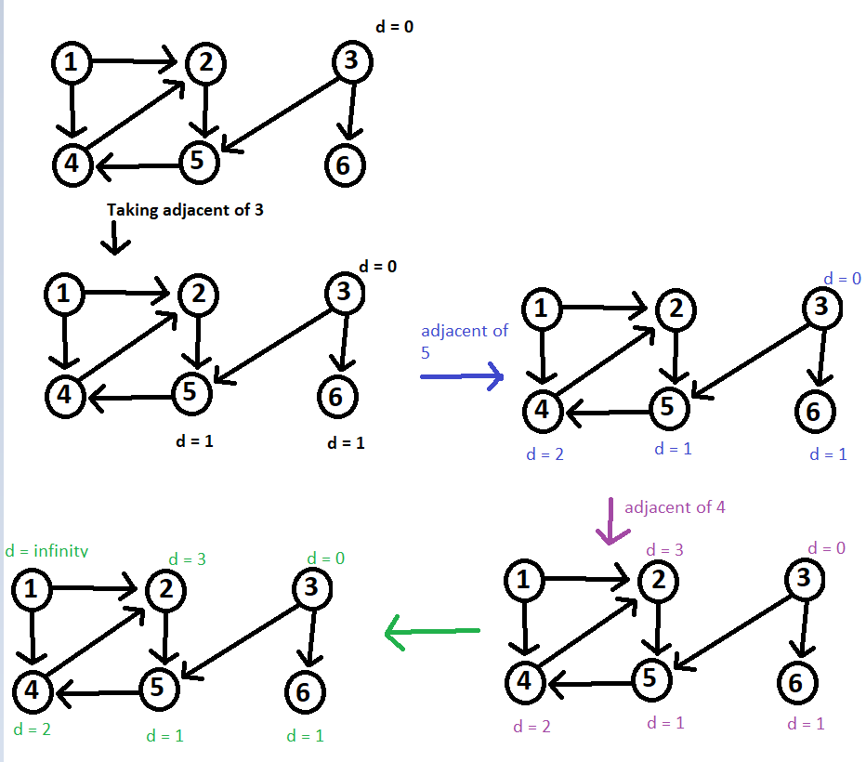

* 1. Explain briefly why the complexity of BFS is *O*(V+E).

Because while BFS, each vertex is visited once at most and each time a vertex is explored we need to visit each edge from the current vertex so each edge can be visited twice and thus it takes O(V+E) time to explore each vertex and edge.

1. **Bellman-Ford Algorithm** Consider the following graph

a

b

c

d

e

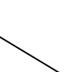

‐4

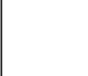

2

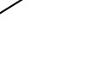

1

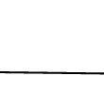

5

3

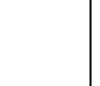

‐3

* 1. Give the adjacency matrix of the graph. 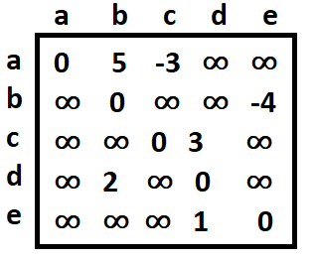
  2. Run Bellman-Ford algorithm on the graph, using vertex a as the source. In each pass, relax the edges in the order (*a*, *b*), (*a*, *c*), (*d*, *b*), (*c*, *d*), (*d*, *e*), (*e*, *d*).

